### 3.2.1. Power Supply Subsystem

#### 3.2.1.1. Solution Approach

This subsystem is for distribute power towards other subsystems at required voltage level and with specified current limitations. The power subsystem is composed of 2 LiPo batteries. As is known, our project consists of 2 separate parts which are controller side and robot side. Controller has “3s 900Mah LiPo” and the robot has “3s 2900Mah LiPo”. Both sides uses LiPo for supplying power to Arduino’s and other subsystems’ components. In Figure 3.2.1.1.1., the one Li-Po cell can be seen.



Figure 3.2.1.1.1: Example of 3 cells Li-Po Pack [4]

The motor draws a much higher current at maximum 2A. Connecting directly with Arduino will result in not working motor and destroying Arduino due to high currents. Hence we used L298N Motor Drivers for supplying this current with Li-Po cells. The models can be seen in Figure 3.2.1.1.2.

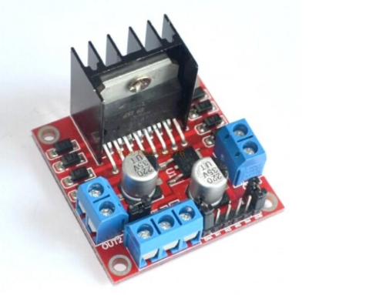

Figure 3.2.1.1.2: L298n dual motor driver [5]

#### 3.2.1.2. Block Diagram and Flow Chart

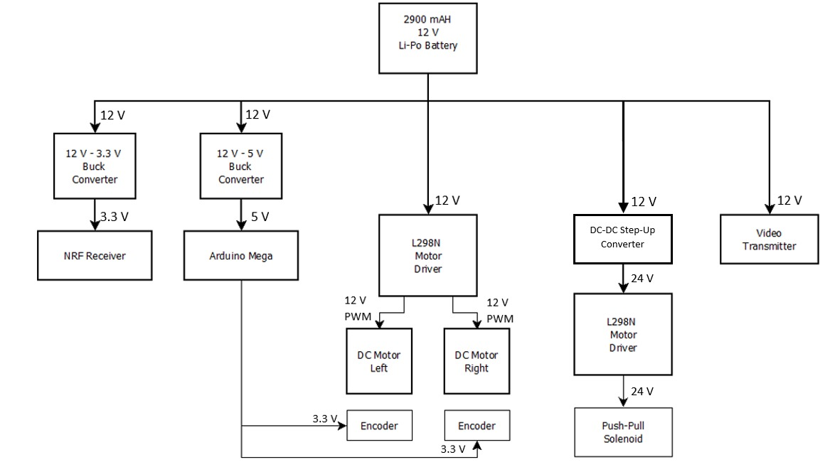

*Figure 3.2.1.2.1: Block Diagram of Power Supply System*

### 3.2.3. Shooting Subsystem

#### 3.2.3.1. Solution Approach

The electrical energy stored in the batteries has to be transformed in mechanical energy to move the ball. In this system which is solenoid actuated, self-inductance is used. A current is send through a coil which generates a magnetic field. This field can be increased by increasing the number of windings of the coil or by increasing the current through the coil. With this magnetic field, a ferromagnetic material can be attracted or repulsed. The shooting mechanical system design can be seen in Figure 3.2.3.1.1.

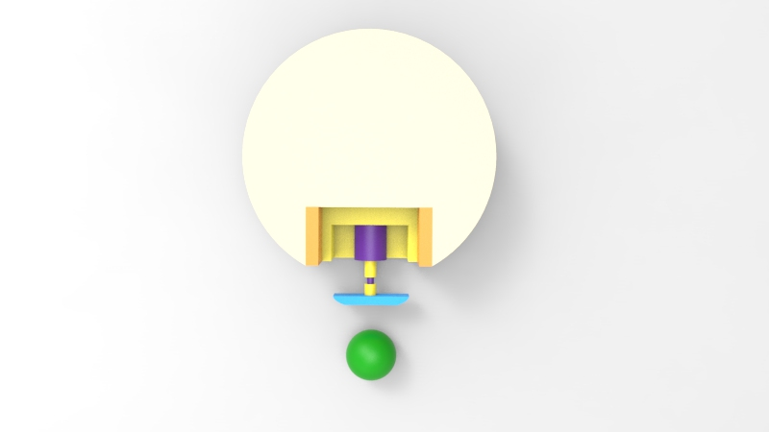

Figure 3.2.3.1.1: Top view of shooting mechanical system design

When a current is sent through a loop of a wire, a magnetic field is build. A solenoid is based on this principle, shown in Figure 3.2.3.1.2. It contains a lot of loops of wire, forming a coil, producing a magnetic field when an electrical current is send through it. The plunger is used to provide a mechanical force which will be used to kick the ball. The force applied to the plunger by the coil is proportional to the change in current, radius and length of the coil. Also we used striker plate which increases the surface are of the kicker, increasing the chance of it making contact with the ball.

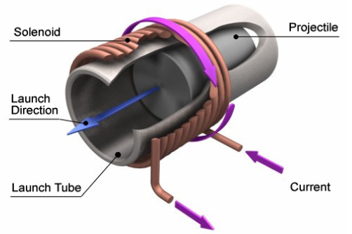

Figure 3.2.3.1.2: A schematic representation of a solenoid [1]

Also the working principle for how to drive solenoids with Arduino can be seen in Figure 3.2.3.1.3. This schematic is given by supplier with some notes. These are:

1. You will most likely need a heat sink on the transistor.
2. This diagram is for DC solenoids rated up to about 24W: i.e. 12V@2A, 6V@4A etc.
3. The protection diode should preferable be a schottky type.

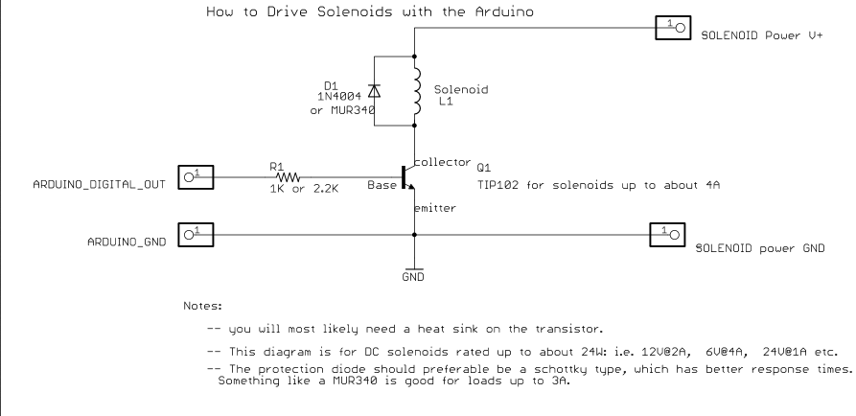

Figure 3.2.3.1.3: The schematic of solenoids with Arduino connections [2]

#### 3.2.3.1. Block Diagram and Flow Chart

As can be seen in Block Diagram in Figure 3.2.3.1.1, Dc to Dc converter is used for upgrading DC voltage to hit the ball with more voltages. Also Flow Chart of shooting system can be seen in Figure 3.2.3.1.2.

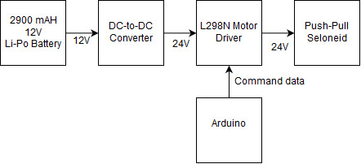

Figure 3.2.3.1.1: Block Diagram of Shooting System

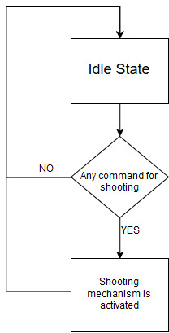

Figure 3.2.3.1.2: Flow Chart of Shooting System

REFERENCES

[1] Figure 3.2.3.1.2 Retrieved from <http://www.mate.tue.nl/mate/pdfs/6971.pdf>.

[2] Figure 3.2.3.1.3 Retrieved from <https://pdf.direnc.net/upload/solenoid-driver-adafruit.pdf>.

[3] <http://mech.vub.ac.be/multibody/final_works/thesis_joris_de_witte.pdf>

[4] Figure 3.2.1.1.1 Retrieved from <http://www.helipal.com/storm-11-1v-2200mah-35c-pro-series-li-po-battery-xt60.html>.

[5] Figure 3.2.1.1.1 Retrieved from [tronixlabs.com.au](https://tronixlabs.com.au).